Our Saint Nicholas Catholic School has a long and distinguished history of service to the Freedom community. We strive to achieve academic excellence and character development with an emphasis on Catholic faith. Children ages three (by 9/1/22) and four are eligible for our Early Childhood Program. | 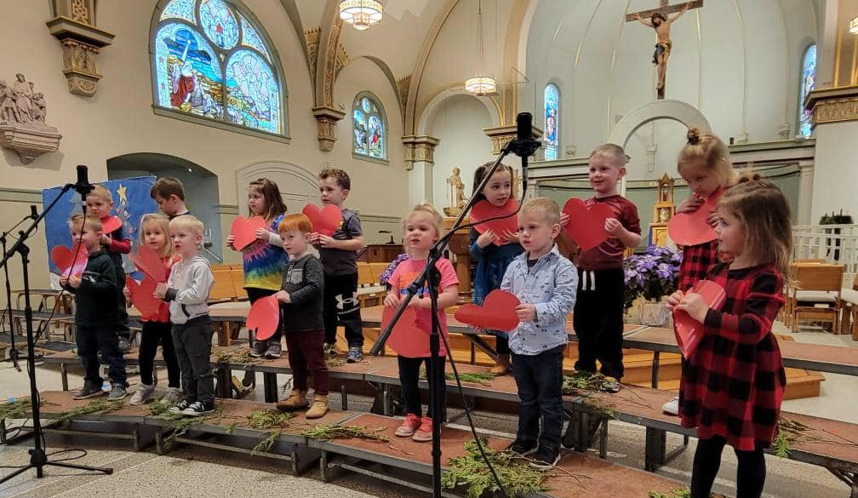

2022-2023 Early Childhood Options for 3- & 4-Year-Old Kindergarten
Hours of Operation: 7:50 AM–3:10 PM
Before Care Available from 7:00–7:40 AM
Aftercare Available from 3:10-5:30 PM
3-Year-Old Kindergarten Options
Before Care  7:00-7:40 AM | Tues-Thursday  (Half Day) | Tues-Thursday  (Full Day) | Aftercare  3:10-5:30 PM
Free | $3,000/year | $3,300/year | $12/day

4-Year-Old Kindergarten Options
Before Care  7:00-7:40 AM | Mon-Fri  (Half Day) | Mon-Fri  (Full Day) | Aftercare  3:10-5:30 PM
Free | $3,000/year | $3,300/year | $12/day
*Please note aftercare will only be charged when student is present.

Please include a $75 down payment for registration (non-refundable) to reserve your spot in our Pre-K3 and our 4K program.

Thank you for considering St. Nicholas Catholic School for your family and your sons/daughters’ education. We are committed to Putting Faith in our Future.

If you have any questions, please contact us
at (920) 788-9371 or
Scott Vanderloop at svanderloop@stnicholasfreedom.org

